

VITHUB: Online Form

**Group Members:**

* Yashasvi Asthana (15BCE1161)
* Suryansh Bhardwaj (15BCE1047)
* Ritwik Kala (15BCE1114)

**About the project:**

This project is developed to help the students in VIT so that they can share files. It is a forum where students can upload any files (documents, movies, songs presentations and many more) which they wish to share among other students. The student who is uploading the file can also restrict its access. He/she can protect the file using a password. The admin will have rights to remove unacceptable contents and even rearrange the order in which they are being displayed. The admin has rights to start a category in which the students can upload their files according to the category of the file. If a student wants a category to be started, he/she can directly message to the admin regarding the same.

**Main Login Page:**

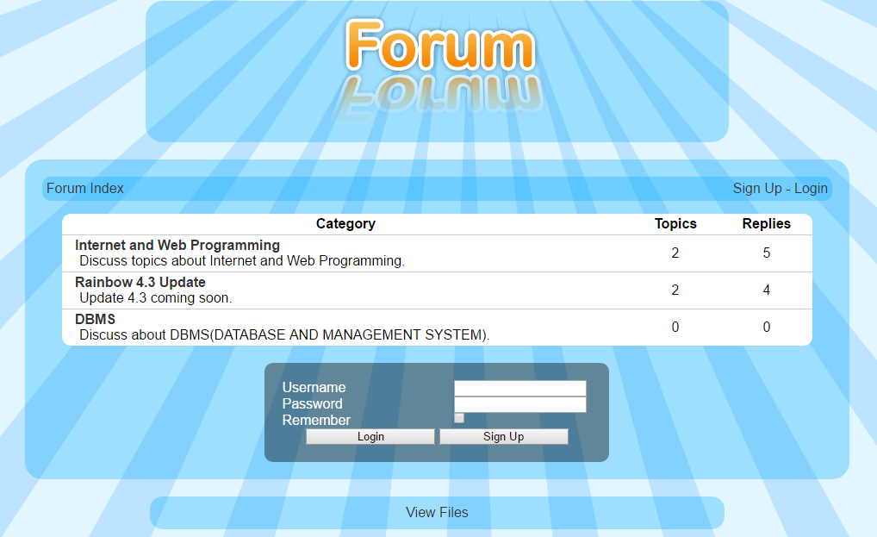

**Admin Login view:**

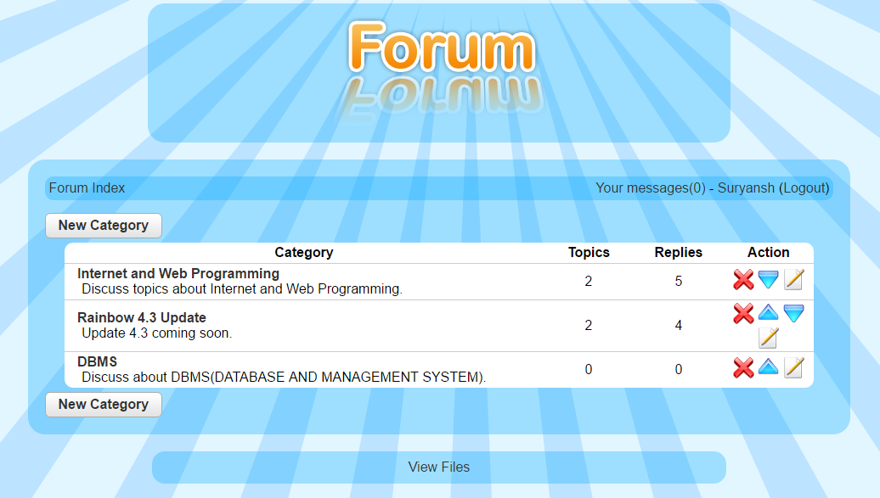

Admin can have certain actions displayed along with the categories that he can perform. Like delete, change order and edit.

**User Login view:**

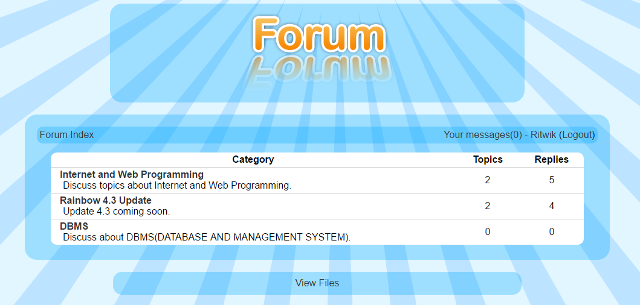

Total topics and replies are listed with respect to the categories, visible to all users.

**Creating a new category:**

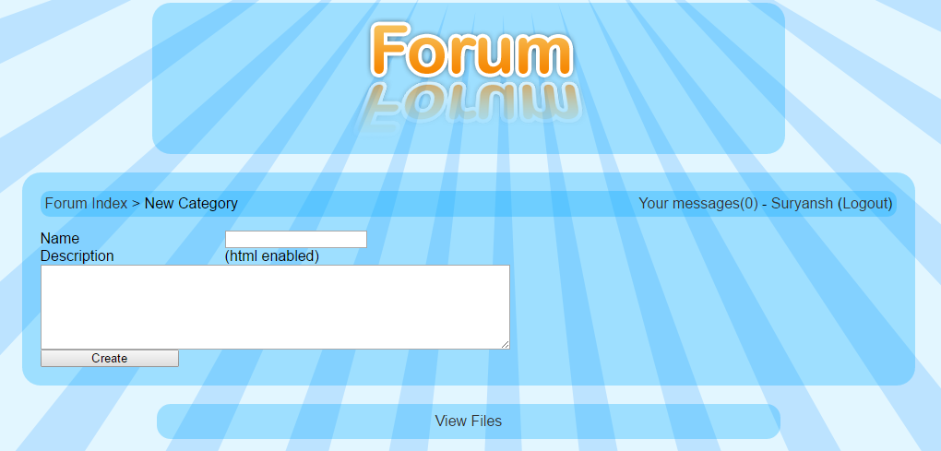

Here admin is logged in and is creating a category.

**Sending message to Admin:**

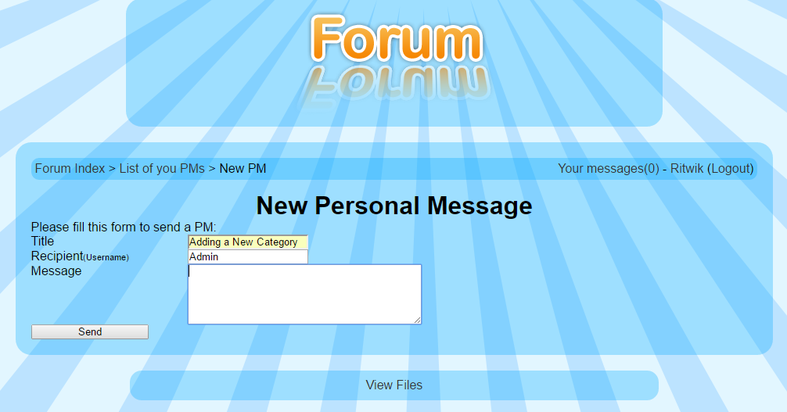

Here a user is requesting the admin to create a new category.

**Topic view of user:**

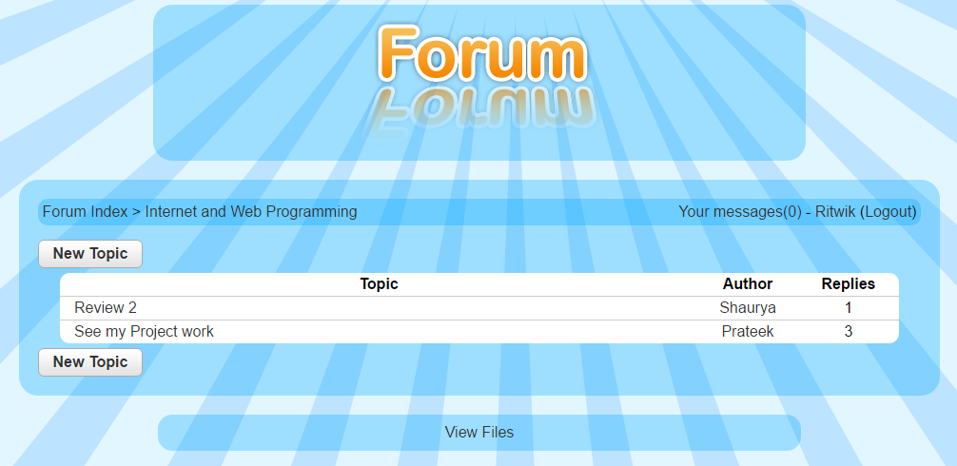

These are the topics inside a category. Topics can be added by the users.

**Post view of user:**

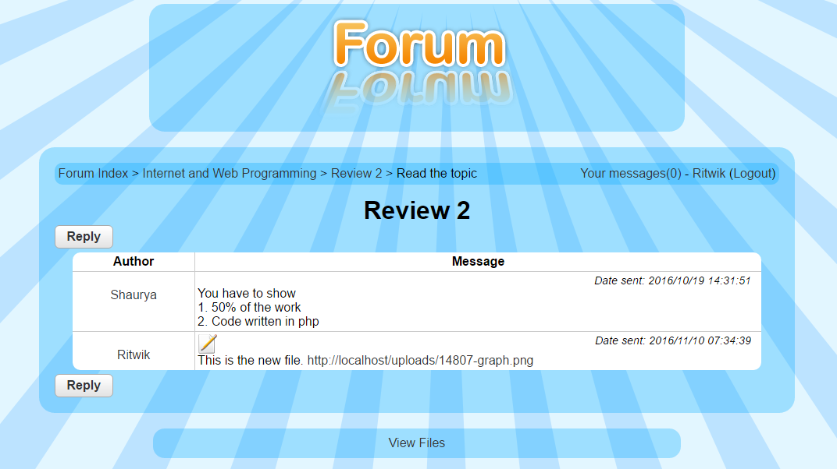

**List of all users:**

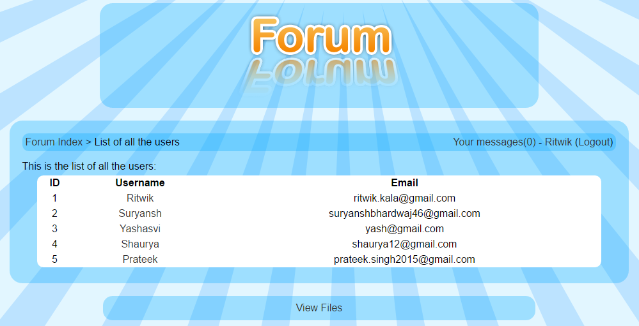

List of all the users is visible to all the users.

**POSTER:**



VITHUB: Online Forum

Ritwik Kala, Yashasvi Asthana,Suryansh Bhardwaj

Prof. Rajiv Vincent

**School of Computing Science and Engineering**

**Introduction**

The main objective behind this project was to provide a reliable online forum that is robust and flexible. We have created a website for this purpose. The interactive graphical user interface and the overall simplicity of the website makes it easier for students to use and share their files among each other.

**Methodology**

VITHUB is an online Forum for students exclusively for VIT Students to share any type of files on the forum.

The interface of the website was made using HTML, CSS, Javascript and PHP. The Database was designed using MySQL and PHP was used to connect the Front-End and Back-End. 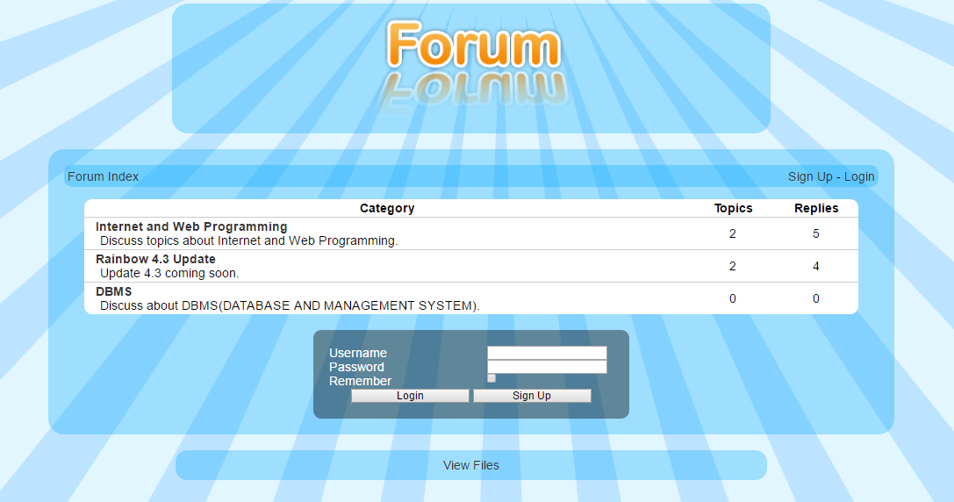

**Scope of Project**

The scope our project is to provide an online forum.This will allow the studentsto share their files on the forum. Students can upload any type of file on the forum by logging in to the website.The administrators have the right to update or modify students’ progress and actions.

**Contact Details**

[ritwik.kala2015@vit.ac.in](mailto:ritwik.kala2015@vit.ac.in)

[yashasvi.ashthana2015@vit.ac.in](mailto:yashasvi.ashthana2015@vit.ac.in)

suryansh.bhardwaj2015@vit.ac.in

**Conclusion**

This project was not possible without the help and support from the faculty who assigned us and guided us during this project. We were successfully able to implement the basic functionality and provide an interesting website for all the students of VIT.

**Results**

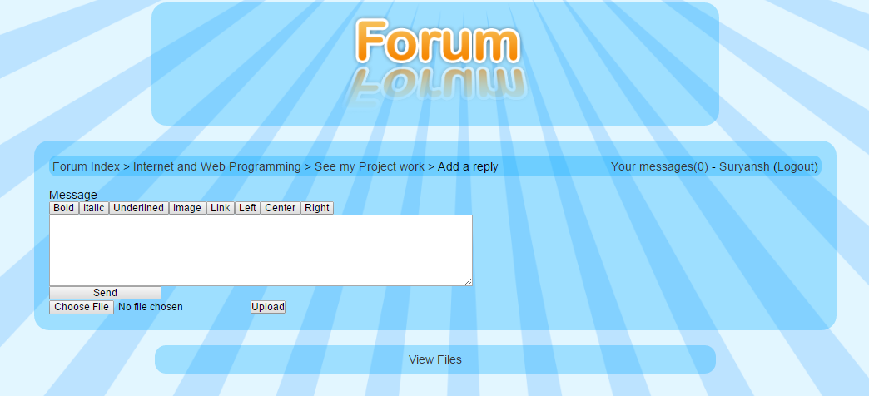 This is a website to share files among students. The students can upload any type of file in the New Reply Page

